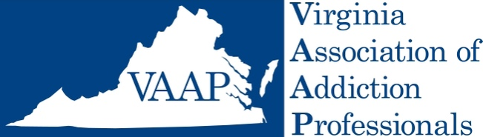

Advocacy Initiative – Recovery Residence Reform
General talking points:

Background Information:

Department of Behavioral Health and Development Services (DBHDS) - the Commonwealth agency tasked with certifying Recovery Residences in Virginia.
- Publishes a list of certified Recovery Residences on its web site.
- Delegated the certification process and currently accepts as “certified” any Recovery Residence that is certified by either Oxford House or Virginia Association of Recovery Residences (VARR).
- They have no internal agency certification process or standards, so they rely on VARR or Oxford to vouch for the residences as meeting appropriate standards.
- They have no independent inspection or verification process for Recovery Residences.
- VARR is affiliated with NARR which is the national standard for recovery residences. They have no affiliation with the houses that they certify.
- Oxford Houses are chartered through the Oxford House Charter agreement process, a process more like self-certification.
- The standards for certification between Oxford and VARR are vastly different.
- Of these 2 entities, VARR appears to have a more robust set of certification criteria, training, and inspection accountability and process.

Advocacy Steps: How to Improve this System and Ensure Standard Certification Criteria:

- DBHDS should establish a uniform set of certification criteria for all Recovery Residences in Virginia
- All certification criteria should be available to the public through DBHDS.
- Transparency for each recovery house on their process for certification and the standards, verification inspections, dates of certification, etc. should be required to be available to each prospective resident and available on the DBHDS web site.
- DBHDS needs appropriate resources and funding to provide adequate oversight of certified Recovery Residences.
  - DBHDS reports that it has drafted a position description for such oversight but that it has received no funding to create and fill this position to date.
- Recovery Residences should be required to report serious incidents to the certifying agency (DBHDS). These events should be available to the public through the DBHDS web site.

Recently, a blog known as the Parham Papers, alleged corruption and fraudulent practices by VARR leadership. The validity of these allegations has not been established to date – and this is a red herring issue for the purposes of Recovery Residence Certification. Our concern is the establishment of uniform and proper standards for certification and providing independent oversite by the DBHDS.

